**Name:-** Gaurang Raorane **Div:-** D15A

**Roll No:-** 49 **Batch:-** C

**EXPERIMENT 12**

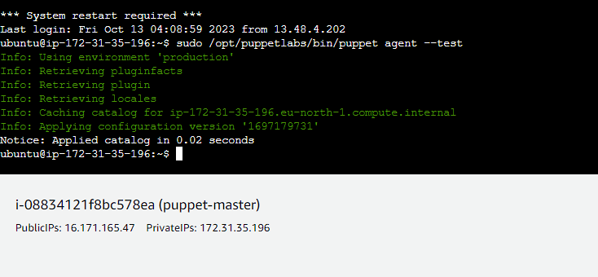

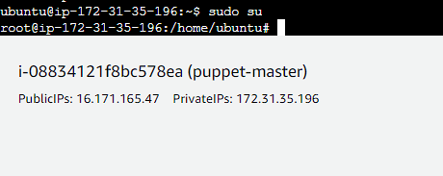

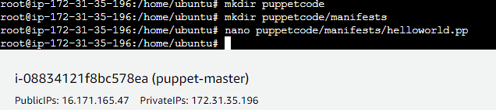

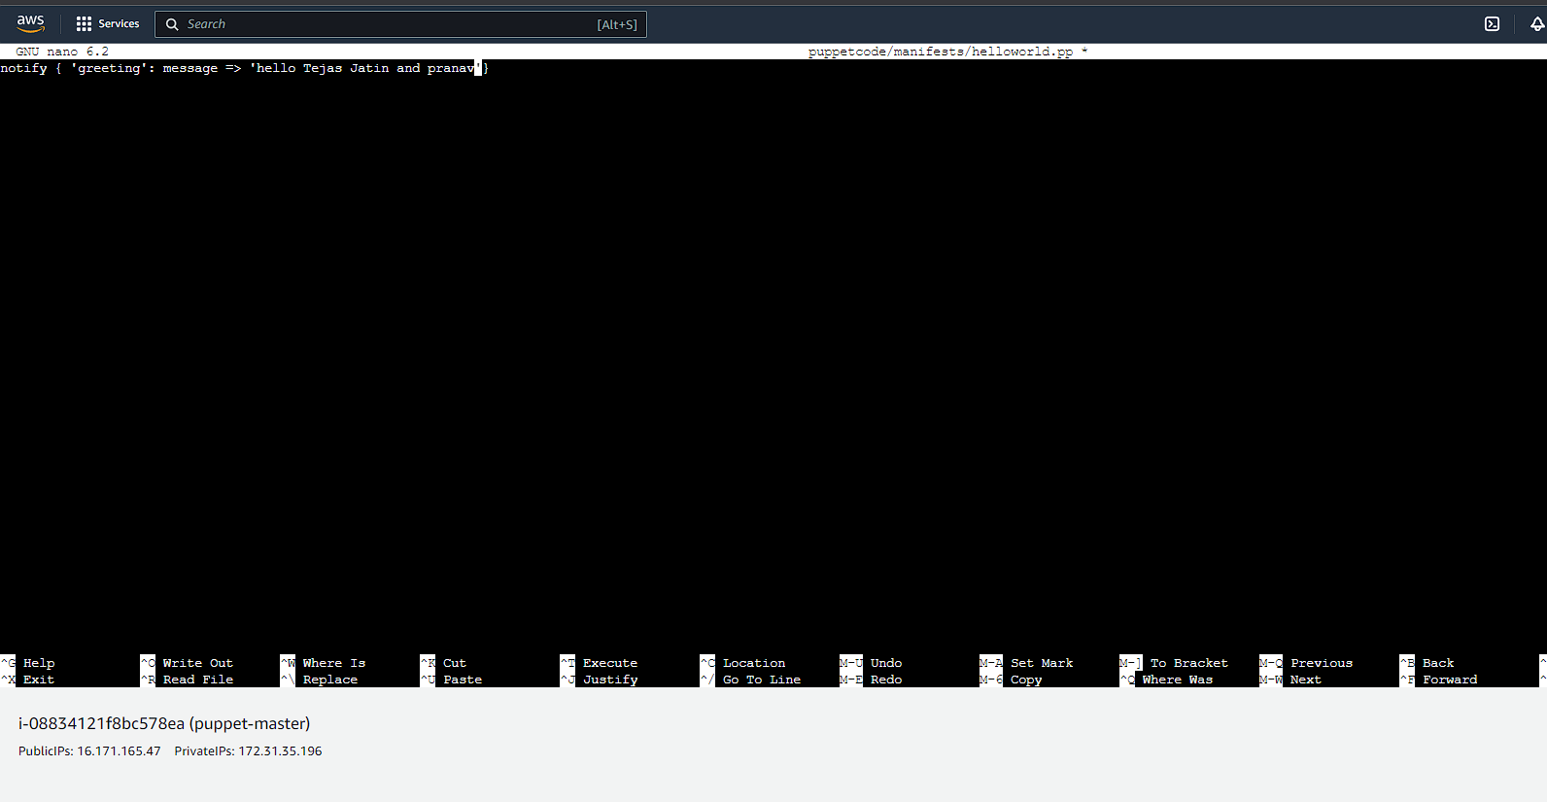

Now go to /opt/puppetlabs/puppet/bin: cd /opt/puppetlabs/puppet/bin

